WEEK 1
Data Structures And Algorithms

Name: Rajesh A
Superset ID: 6384182

Exercise 1: Inventory Management System(.NET)

Scenario:

You are developing an inventory management system for a warehouse. Efficient data storage and retrieval are crucial.

What I Learned
I learned how to build a basic inventory management system in C# using classes and collections. This program demonstrates adding, updating, deleting, and displaying products using a dictionary for efficient item access by product ID.

CODE:

using System;
using System.Collections.Generic;

namespace InventoryManagement
{
class Product
{
public int ProductId;
public string ProductName;
public int Quantity;
public double Price;
}

class Inventory
{
private Dictionary<int, Product> products = new();

public void AddProduct(Product product) => products[product.ProductId] = product;
public void UpdateProduct(int id, Product updatedProduct) => products[id] = updatedProduct;
public void DeleteProduct(int id) => products.Remove(id);
public void DisplayInventory()
{
foreach (var p in products.Values)
Console.WriteLine($"{p.ProductId} - {p.ProductName} - {p.Quantity} - {p.Price}");
}
}

class Program
{
static void Main()
{
Inventory inventory = new();
inventory.AddProduct(new Product { ProductId = 1, ProductName = "Mouse", Quantity = 50, Price = 300 });
inventory.AddProduct(new Product { ProductId = 2, ProductName = "Keyboard", Quantity = 20, Price = 600 });
inventory.UpdateProduct(1, new Product { ProductId = 1, ProductName = "Wireless Mouse", Quantity = 40, Price = 500 });
inventory.DeleteProduct(2);
inventory.DisplayInventory();
}
}
}

OUTPUT:

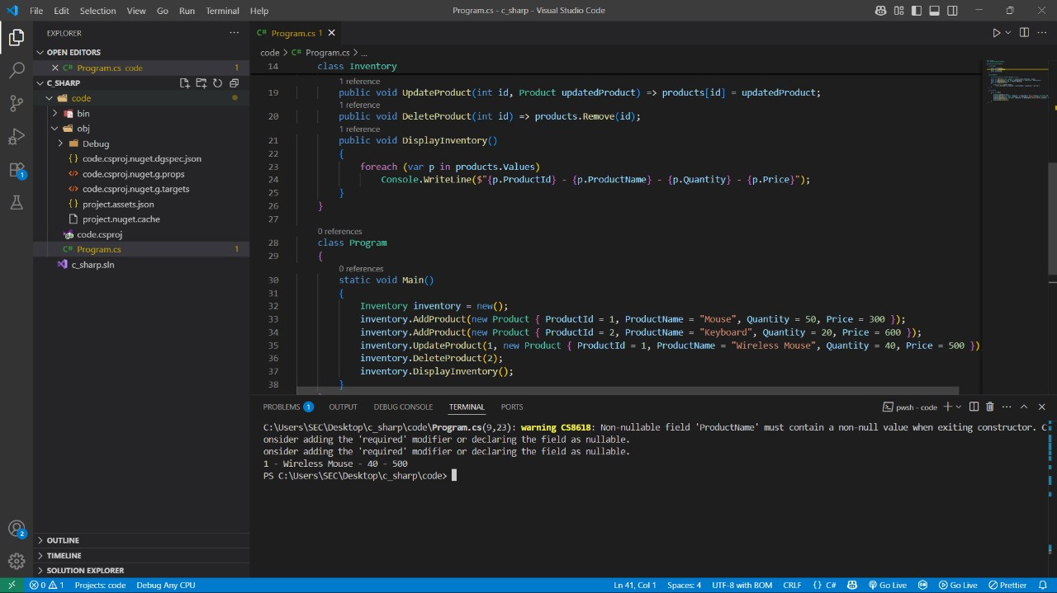

Conclusion
The inventory system performs basic product management operations efficiently using a dictionary for fast access and updates.

Exercise 2: E-commerce Platform Search Function(.NET)

Scenario:
You are working on the search functionality of an e-commerce platform. The search needs to be optimized for fast performance.

What I Learned
I learned how to implement both linear and binary search algorithms in C# to find a product by name. Binary search requires the array to be sorted, offering better performance than linear search on large datasets.
CODE:

namespace SearchFunction
{
class Product
{
public int ProductId;
public string ProductName;
public string Category;
}

class Program2
{
static int LinearSearch(Product[] products, string name)
{
for (int i = 0; i < products.Length; i++)
if (products[i].ProductName == name) return i;
return -1;
}

static int BinarySearch(Product[] products, string name)
{
int left = 0, right = products.Length - 1;
while (left <= right)
{
int mid = (left + right) / 2;
int cmp = string.Compare(products[mid].ProductName, name);
if (cmp == 0) return mid;
if (cmp < 0) left = mid + 1;
else right = mid - 1;
}
return -1;
}

static void Main()
{
Product[] products = {
new Product { ProductId = 1, ProductName = "Camera", Category = "Electronics" },
new Product { ProductId = 2, ProductName = "Phone", Category = "Electronics" },
new Product { ProductId = 3, ProductName = "TV", Category = "Electronics" }
};
Array.Sort(products, (a, b) => string.Compare(a.ProductName, b.ProductName));
Console.WriteLine(BinarySearch(products, "Phone"));
}
}
}

OUTPUT:

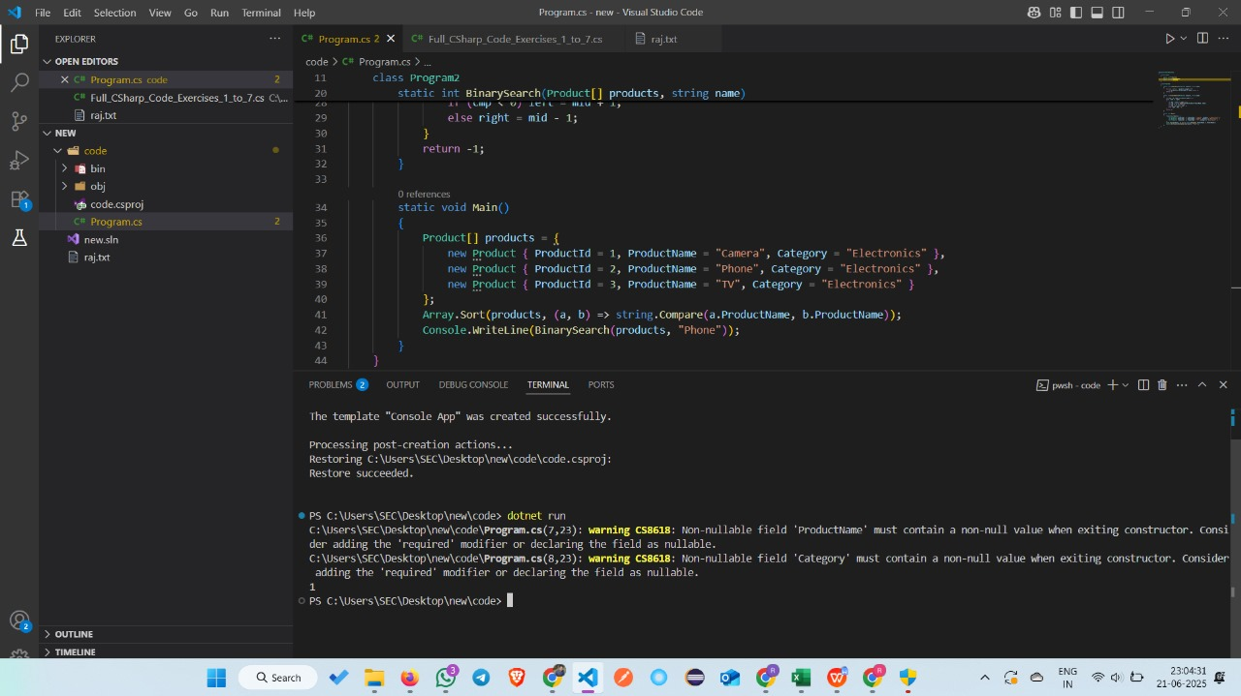

Conclusion
Binary search provides a faster way to locate a product in a sorted list compared to linear search.

Exercise 3: Sorting Customer Orders(.NET)

Scenario:

You are tasked with sorting customer orders by their total price on an e-commerce platform. This helps in prioritizing high-value orders.

What I Learned
I learned how to implement the Quick Sort algorithm in C# to sort a list of orders based on their total price. This algorithm improves performance for large datasets by using a divide-and-conquer approach to sort elements efficiently in-place.

CODE:

namespace SortingOrders
{
class Order
{
public int OrderId;
public required string CustomerName;
public double TotalPrice;
}

class Program3
{
static void QuickSort(Order[] orders, int low, int high)
{
if (low < high)
{
int pi = Partition(orders, low, high);
QuickSort(orders, low, pi - 1);
QuickSort(orders, pi + 1, high);
}
}

static int Partition(Order[] orders, int low, int high)
{
double pivot = orders[high].TotalPrice;
int i = low - 1;
for (int j = low; j < high; j++)
{
if (orders[j].TotalPrice < pivot)
{
i++;
(orders[i], orders[j]) = (orders[j], orders[i]);
}
}
(orders[i + 1], orders[high]) = (orders[high], orders[i + 1]);
return i + 1;
}

static void Main()
{
Order[] orders = {
new Order { OrderId = 1, CustomerName = "A", TotalPrice = 500 },
new Order { OrderId = 2, CustomerName = "B", TotalPrice = 1500 },
new Order { OrderId = 3, CustomerName = "C", TotalPrice = 1000 }
};
QuickSort(orders, 0, orders.Length - 1);
foreach (var o in orders)
Console.WriteLine($"{o.OrderId} - {o.TotalPrice}");
}
}
}

OUTPUT:
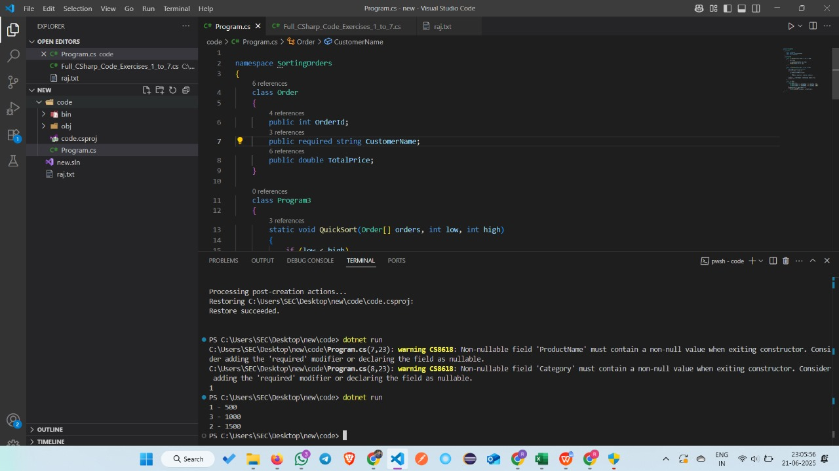

Conclusion
Quick Sort efficiently arranged the orders by total price using recursion and partitioning, making it ideal for large datasets with better average-case performance.

Exercise 4: Employee Management System(.NET)

Scenario:

You are developing an employee management system for a company. Efficiently managing employee records is crucial.

What I Learned
I learned how to create and manage an array of employee records in C#. This program allows adding employees, displaying basic information, and searching for a specific employee by ID using a simple loop.

CODE:

namespace EmployeeSystem
{
class Employee
{
public int EmployeeId;
public string Name;
public string Position;
public double Salary;
}

class Program4
{
static void Main()
{
Employee[] employees = new Employee[100];
int count = 0;

employees[count++] = new Employee { EmployeeId = 1, Name = "John", Position = "Manager", Salary = 70000 };
employees[count++] = new Employee { EmployeeId = 2, Name = "Jane", Position = "Clerk", Salary = 40000 };

for (int i = 0; i < count; i++)
Console.WriteLine($"{employees[i].EmployeeId} - {employees[i].Name}");

for (int i = 0; i < count; i++)
if (employees[i].EmployeeId == 1)
Console.WriteLine("Found: " + employees[i].Name);
}
}
}

OUTPUT:

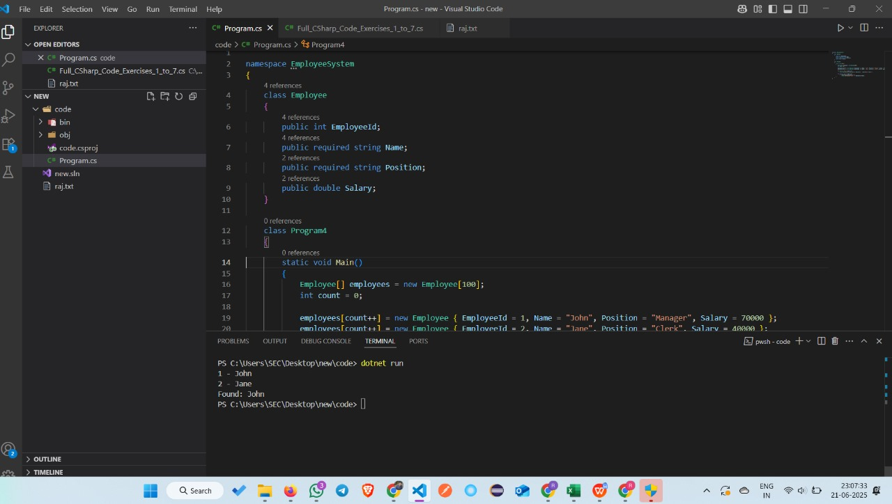

Conclusion
This program provides basic employee record handling with add, display, and search functionalities using a static array.

Exercise 5: Task Management System(.NET)
Scenario:
You are developing a task management system where tasks need to be added, deleted, and traversed efficiently.

What I Learned:
I learned how to use a singly linked list to manage tasks in C#. The program demonstrates adding tasks to the front, traversing all tasks, searching a task by ID, and deleting a task from the list dynamically using reference links.
CODE:
using System;
class Task
{
public int TaskId;
public required string TaskName;
public required string Status;
public required Task Next;
}

class TaskList
{
private Task? head;

public void AddTask(int id, string name, string status)
{
Task newTask = new Task { TaskId = id, TaskName = name, Status = status, Next = head };
head = newTask;
}

public void Traverse()
{
Task current = head;
while (current != null)
{
Console.WriteLine($"{current.TaskId} - {current.TaskName} - {current.Status}");
current = current.Next;
}
}

public Task Search(int id)
{
Task current = head;
while (current != null)
{
if (current.TaskId == id) return current;
current = current.Next;
}
return null;
}

public void Delete(int id)
{
Task current = head, prev = null;
while (current != null && current.TaskId != id)
{
prev = current;
current = current.Next;
}
if (current == null) return;
if (prev == null) head = head.Next;
else prev.Next = current.Next;
}
}

class Program5
{
static void Main()
{
TaskList list = new TaskList();
list.AddTask(1, "Design", "Pending");
list.AddTask(2, "Development", "In Progress");
list.AddTask(3, "Testing", "Not Started");
list.Traverse();
Console.WriteLine("After Deleting Task 2");
list.Delete(2);
list.Traverse();
}
}
OUTPUT:

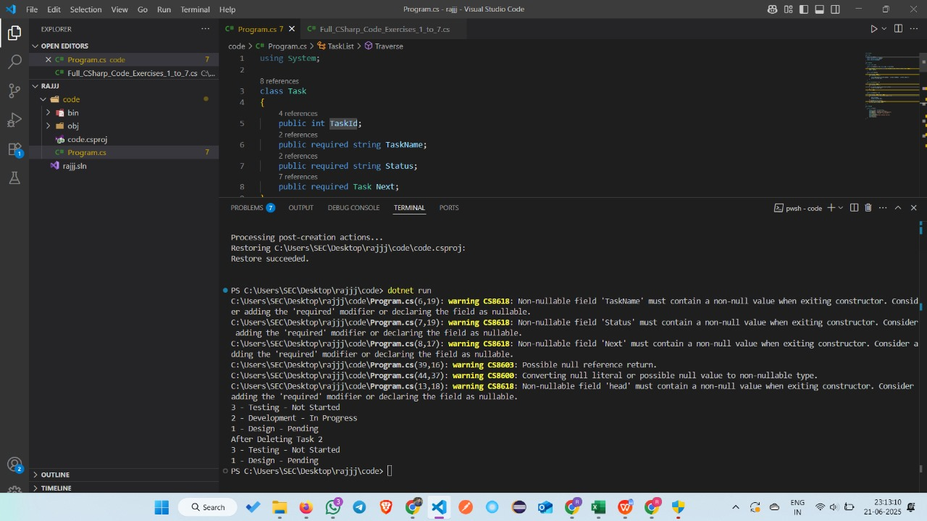

Conclusion:
The program efficiently handles dynamic task operations like insertion, deletion, and searching using a singly linked list.

Exercise 6: Library Management System(.NET)
Scenario:
You are developing a library management system where users can search for books by title or author.

What I Learned:
I learned how to implement both linear and binary search algorithms in C# to find books by title. Linear search works on unsorted arrays, while binary search requires sorting and offers better performance for large datasets.

CODE:
using System;

class Book
{
public int BookId;
public string Title;
public string Author;
}

class Program6
{
static int LinearSearch(Book[] books, string title)
{
for (int i = 0; i < books.Length; i++)
if (books[i].Title == title) return i;
return -1;
}

static int BinarySearch(Book[] books, string title)
{
int left = 0, right = books.Length - 1;
while (left <= right)
{
int mid = (left + right) / 2;
int cmp = string.Compare(books[mid].Title, title);
if (cmp == 0) return mid;
if (cmp < 0) left = mid + 1;
else right = mid - 1;
}
return -1;
}

static void Main()
{
Book[] books = {
new Book { BookId = 1, Title = "Algorithms", Author = "Cormen" },
new Book { BookId = 2, Title = "C#", Author = "Anders" },
new Book { BookId = 3, Title = "Java", Author = "Gosling" }
};

Console.WriteLine("Linear Search: " + LinearSearch(books, "Java"));

Array.Sort(books, (a, b) => string.Compare(a.Title, b.Title));
Console.WriteLine("Binary Search: " + BinarySearch(books, "Java"));
}
}
OUTPUT:

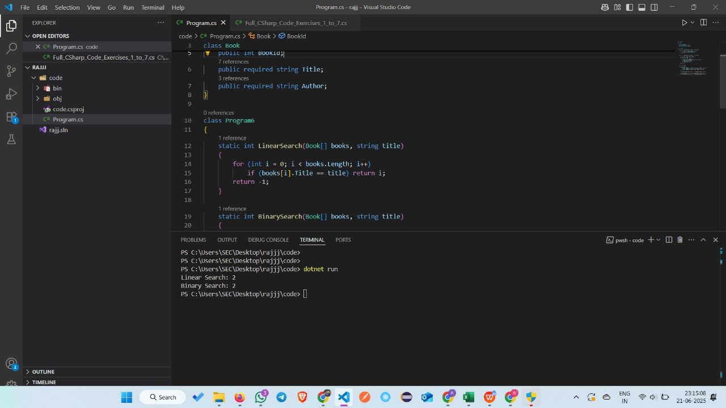

Conclusion
This program demonstrates effective searching in book data using linear and binary search, highlighting the importance of sorting for efficient binary lookup.

Exercise 7: Financial Forecasting(.NET)

Scenario:
You are developing a financial forecasting tool that predicts future values based on past data.

What I Learned
I learned how to use both recursion and memoization to predict investment growth over time. Recursion recalculates values repeatedly, while memoization improves efficiency by storing intermediate results to avoid redundant computations.

CODE:

using System;

class Program7
{
static double PredictRecursive(int year, double rate)
{
if (year == 0) return 1000;
return PredictRecursive(year - 1, rate) * (1 + rate);
}

static double PredictMemo(int year, double rate, double[] memo)
{
if (memo[year] != 0) return memo[year];
if (year == 0) return memo[year] = 1000;
return memo[year] = PredictMemo(year - 1, rate, memo) * (1 + rate);
}

static void Main()
{
Console.WriteLine("Recursive Value: " + PredictRecursive(5, 0.1));
double[] memo = new double[10];
Console.WriteLine("Memoized Value: " + PredictMemo(5, 0.1, memo));
}
}

OUTPUT:

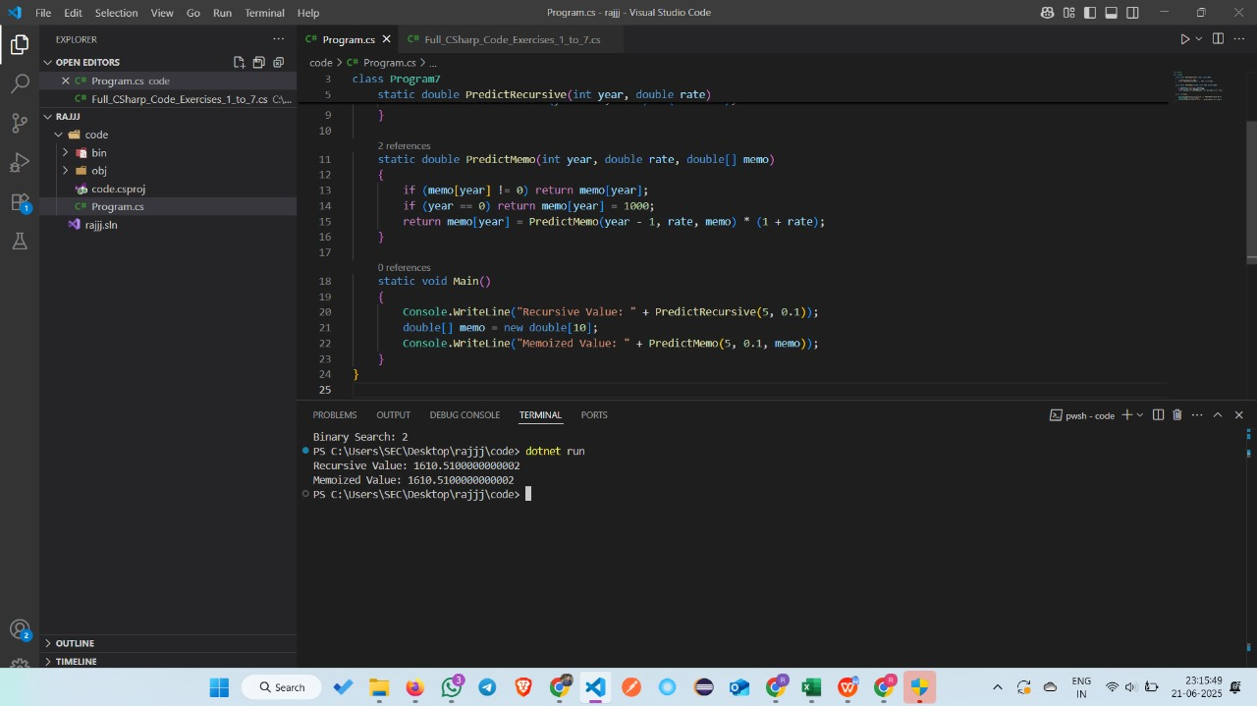

Conclusion:
Memoization significantly reduces the number of recursive calls by caching results, making the investment prediction more efficient.

Thank you

